**Venkata Lakshmi Sasank Tipparaju**

**Student#700738838**

**CS 5600 – CRN: 13892**

1. **The student data file contains the following attributes:**

* **Id: Integer (2 bytes)**
* **Name: Varchar (16) (16 bytes)**
* **Age: Integer (2 bytes)**
* **Phone: Varchar (10) (bytes)**

**There are 1,000 records in this data file. We want to store the data file in a hard drive with the block(page) size = 512 bytes.**

**(Note. Each record is a fixed length record.)**

* 1. **How many blocks or pages that need for storing this data file in a hard drive? (3 pts.)**

***Answer:***

Given block size is 512 Bytes.

Total size of each student record = 2+16+2+10 = 30 Bytes per record

Given total number of student records = 1000 records = 30*1000 = 30000 bytes

*Number of records can be stored in one block = 512/30*

Total number of blocks required to store 30,000 bytes (1000 Student records)

🡺 30,000/512 = 58.59375 🡺 *59 Blocks* required

But let’s say if hard drive has default header of 32 Bytes, then size = 512-32 = 480B

Number of blocks required to store 1000 student records

🡺 30,000/480 = 62.5 🡺 *63 Blocks* required

* 1. **If we store the data file in MySQL, how many blocks or pages that need for the storing? (2 pts.)**

***Answer:***

Page Size in MySQL is 16KB = 16384 Bytes (1KB =1024Bytes)

Total number of blocks required to store 30,000 bytes

🡺 30,000/16384 = 1.831 🡺 *2 Blocks* required

But let’s assume that MySQL has header and trailer ... so that header (38 Bytes) Trailer (8 Bytes)

Then available space = 16,384 – 38 -8 🡺 16,338 Bytes

Total Number of blocks required to store 30,000 bytes of student record = 30,000/16,338 = 1.836 🡺 *2 Blocks are required*

1. **What are the similarities and differences between RAID 0 and RAID 1? (2 pts.)**

***Answer:***

RAID stands for Redundant Array of Independent Disk.

*Differences:*

|  |  |  |
| --- | --- | --- |
|  | RAID 0 | RAID 1 |
| Key feature | Block level data striping with no mirroring or parity. | Data mirroring with no parity or striping |
| Striping | Yes (Evenly splits data across all disks) | No |
| Mirroring, redundancy, and fault tolerance | No No redundancy or fault tolerance. If one drive in the RAID fails, all data is lost. | Yes Two Hard disks are identical, if one fail… it will recover from another hard disk (mirror of first hard disk) |
| Performance | High, offers faster read and write speeds compared with RAID 1. | Normal, slower compared to RAID 0 |
| Storage Space Efficiency | 100% is utilized | Only 50% is utilized, other 50% is for backup through disk mirroring |
| Cost | Less Expensive | More expensive compared to RAID 0 |
| Data Security | Less, as there is no backup | High data security, as there is copy of disk |

*Similarities between Level 0 and Level 1:*

|  |  |  |
| --- | --- | --- |
|  | RAID 0 | RAID 1 |
| Parity Disk | Not used | Not used |
| Number of minimum disks required | 2 | 2 |

1. **Show the buffer’s page allocation using the replacement policy: Least Recently Used-LRU**

**Where buffer size = 3 (3 pts.)**

**Program require: 4, 3, 2, 1, 4, 5, 3, 1, 2, 4**

***Answer:***

**M – Miss, H – Hit**

|  |  |  |  |  |  |  |  |  |  |  |  |  |  |  |  |  |  |  |  |
| --- | --- | --- | --- | --- | --- | --- | --- | --- | --- | --- | --- | --- | --- | --- | --- | --- | --- | --- | --- |
| 4 |  | 3 |  | 2 |  | 1 |  | 4 |  | 5 |  | 3 |  | 1 |  | 2 |  | 4 |  |
| 4 |  | 4 |  | 4 |  | 1 |  | 1 |  | 1 |  | 3 |  | 3 |  | 3 |  | 4 |  |
|  |  | 3 |  | 3 |  | 3 |  | 4 |  | 4 |  | 4 |  | 1 |  | 1 |  | 1 |  |
|  |  |  |  | 2 |  | 2 |  | 2 |  | 5 |  | 5 |  | 5 |  | 2 |  | 2 |  |
| **M** |  | **M** |  | **M** |  | **M** |  | **M** |  | **M** |  | **M** |  | **M** |  | **M** |  | **M** |  |

Miss = 10; Hits = 0; Miss Rate = 10/10 = 100%

1. **Show the buffer’s page allocation using the replacement policy: Most Recently Used-MRU Where buffer size = 3 (3 pts.)**

**Program require: 1, 2, 4, 1, 2, 5, 3, 2, 4, 1**

***Answer:***

**M – Miss, H – Hit**

|  |  |  |  |  |  |  |  |  |  |  |  |  |  |  |  |  |  |  |  |
| --- | --- | --- | --- | --- | --- | --- | --- | --- | --- | --- | --- | --- | --- | --- | --- | --- | --- | --- | --- |
| 1 |  | 2 |  | 4 |  | 1 |  | 2 |  | 5 |  | 3 |  | 2 |  | 4 |  | 1 |  |
| 1 |  | 1 |  | 1 |  | 1 |  | 1 |  | 1 |  | 1 |  | 1 |  | 1 |  | 1 |  |
|  |  | 2 |  | 2 |  | 2 |  | 2 |  | 5 |  | 3 |  | 2 |  | 2 |  | 2 |  |
|  |  |  |  | 4 |  | 4 |  | 4 |  | 4 |  | 4 |  | 4 |  | 4 |  | 4 |  |
| **M** |  | **M** |  | **M** |  | **H** |  | **H** |  | **M** |  | **M** |  | **M** |  | **H** |  | **H** |  |

Miss = 6; Hits = 4; Miss Rate = 60%, Hits Rate = 40%

1. **Create the B-Tree Index(m=4) after insert the following input index: (7 pts.)**

**12, 13, 10, 5, 6, 1, 2, 3, 7, 8, 9, 11, 4, 15, 19, 16, 14, 17.**

***Answer:***

m = 4

min = ⌈4/2⌉ = 2

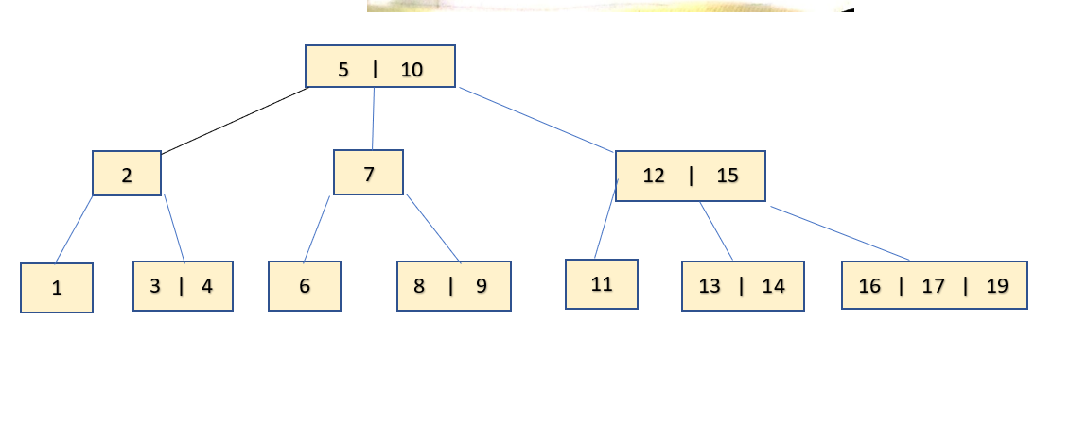

1. **Regarding to the following B-Tree Index(m=4):**

**If we delete index key 6, 3, and 7 what is the B-Tree Index after the deletion? (3 pts.)**

***Answer:***

1. **Regarding to the following B-Tree Index(m=3):**

**If we delete index key 11 and 5, what is the B-Tree Index after the deletion? (2 pts.)**

***Answer:***

7

3

13

15

10 | 12

6

2